**Developing a python script**

|  |  |
| --- | --- |
| Date | 17 Nov 2022 |
| Team Id | PNT2022TMID46546 |
| Title | Hazardous Area Monitoring for Industrial Plant using IoT |

**Python Code**

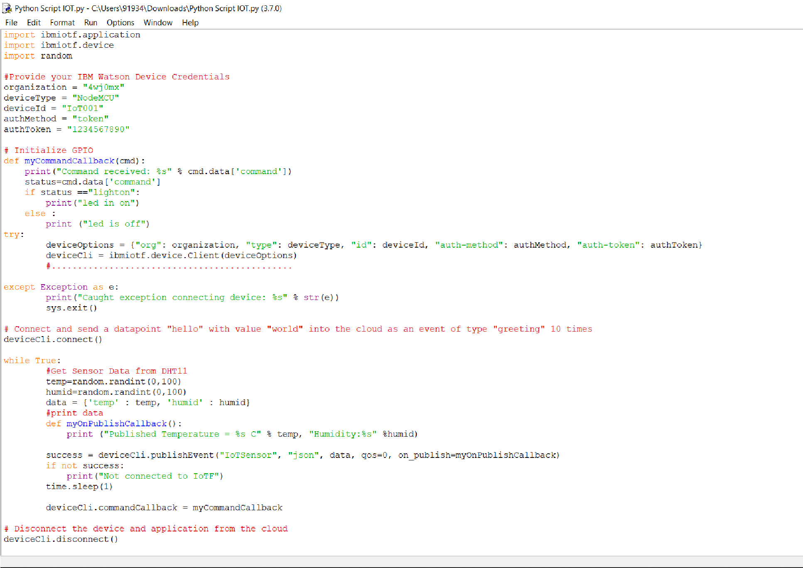

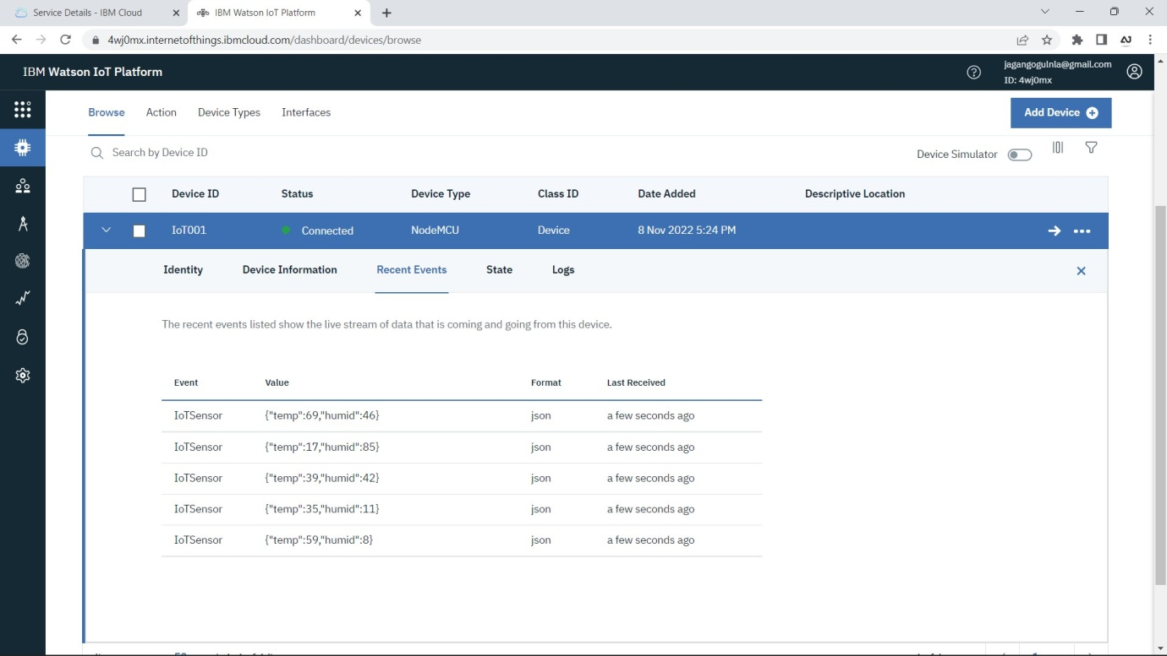**Generated Values**

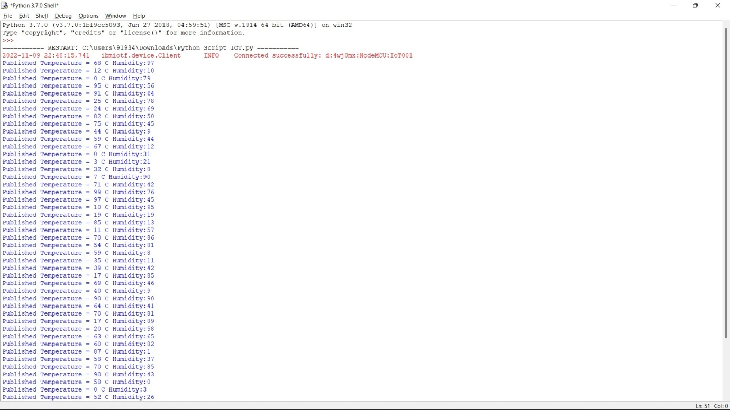

**Publishing the value to IBM cloud**